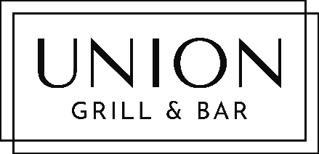

NEW YEAR’S EVE DINNER

Spend this very special evening with Union Grill and celebrate New Year
in absolute style with a glamorous 5-course dinner.

Table reservations available from 7pm.
Dress To Impress.
​$85pp + gratuities
​

Amuse Bouche
​*
Negroni-cured Salmon, Tobiko, Grapefruit Creme Fraiche, Blini
​*
Cassis, Blackcurrant & Mint Sorbet (ve)
*

Smoked Duck Carpaccio, Chambord & Raspberry Dressing

*

Herb-crusted Rack of Lamb, Dauphinoise, Sauteed French Beans, Lamb Jus

or

Seabass, Blue Crab & Black Rice Thai ‘Risotto’
​*
Iced Berries, Warm White Chocolate & Limoncello Sauce (ve)

RESERRVATIONS ESSENTIAL: 640 5660

